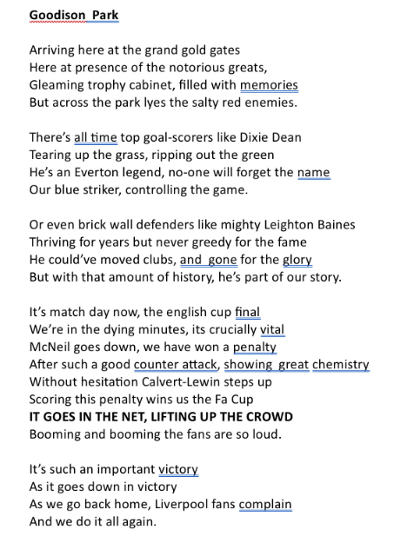

***By Sebastian Fitzwilliam***